WEEK PROGRAMME

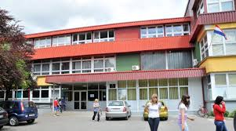

SREDNJA STRUKOVNA ŠKOLA VARAŽDIN

: +38542492255

: sss@sss-vz.hr

: www.ss-strukovna-vz.skole.hr

Monday 18th March– Welcome to Varaždin!
8:30 - Meeting at school
9:00-11:00 - Opening ceremony, introduction; short presentation of the project and partners; tour around the school
11:15-12:00 - Visit to the Varaždin county local government and meeting the officials
12:00 -14:00 - Tour of the town; visit to the town museum 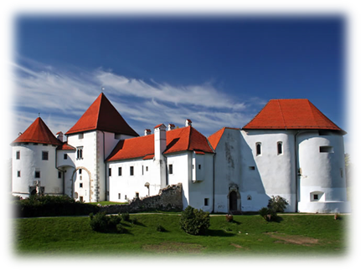
From 14:00 - Free time
17:30 - Meeting at the school
18:00-21:00 - International night at the school
Tuesday 19th March
8:00 – Meeting at the school
8:30 -18:00 – Daily trip to the region of Hrvatsko zagorje- the town of Lepoglava, visit to the museum of Neanderthal man in Krapina; the castle of Trakošćan, lunch
Price per person – 29 Euro
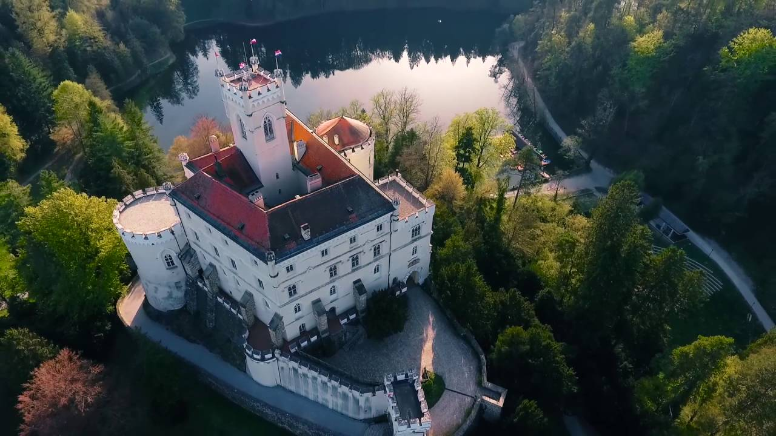

Wednesday 20th March
8:30 - Meeting at school
9:00-10:00 – Students` presentations of the partner schools
10:00-10:30 - Coffee break
10:30-12:00 - Students-workshops; teachers-working on the guide
12:00-12:15– Coffee break
12:15 -14:00 – Students-workshops; teachers-working on the guide
14:15 – Lunch
Price per person 10 Euro
Around 15:00– Students are free for the rest of the day; teachers go back to school to continue with the guide if necessary

Thursday, 21st March
8:00– Meeting at the school
9:00 – Departure for Zagreb
11:00 -18:00 - Daily visit to Zagreb, city tour, Museum of illusions, lunch, free time
Around 20:00 - Arrival to Varaždin
Price per person – 28 Euro

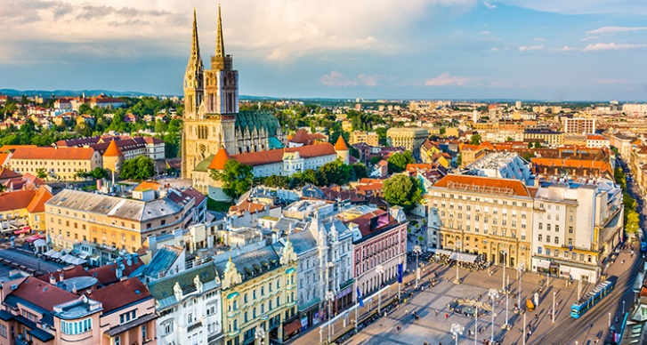

Friday 22nd March
8:30 – Meeting at school
9:00-10:30 – Presentations of students`posters-Ideal school
10:30-10:45 - Coffee break
10:45-11:30 - Evaluation and closure
(choosing the best poster; online quiz)
11:35 -14:00 - Students- visitation to classes
Teachers-how to make Varaždinski klipić- workshop at the school`s bakery
14:00-17:00 - Free time
17:00 - Meeting at the school
18:00 -21:00 - Farewell dinner, certificate ceremony
Bus per person – 2,5 euro
Diner per person – 15 Euro

